**1011 Major Project Lab Report**

Kiet Le

YouTube Video Link: <https://youtu.be/amZQnNcVPbk>

**Introduction:**

While trying to come up with a major project, I went through a lot of thinking, trial and error to get to what I now call the Ultrasonic Buzzer (USB). Or what other people call a motion sensor. My major project is a buzzer and LED that activates when an ultrasonic sensor detects a change in distance.

**Context:**

Motion sensors are used for many different reasons and in many different fields. Your house probably has multiple motion sensors setup for reasons that could include automatic lights and a security system. The ultrasonic sensor is my take on motion sensors using an ultrasonic sensor that will detect if there is a change in distance and then activate actuators of my choosing, which for me are an LED and a buzzer.

**Technical Requirements/Specifications**

Project abilities:

* Senses change in distance in front of device using ultrasonic sensor.
* Blinks an LED when change in distance is sensed.
* Makes a buzzer sound when change in distance is sensed.
* Press button to stop code therefore stopping the ultrasonic sensing, LED, and buzzer.

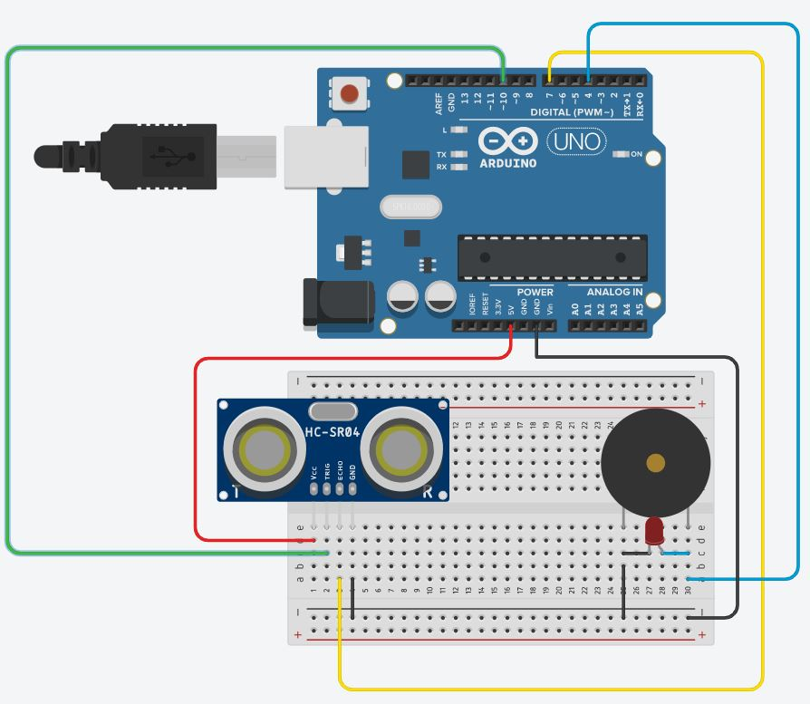

Figure 1 Schematic of Ultrasonic Buzzer. Note: Arduino Uno is in picture. Grove Board is what I used. Most Arduinos should work the same.

**Component List:**

* Arduino Grove Board (1x)
* Ultrasonic sensor HC-SR04 (1x)
* LED (1x)
* Buzzer (1x)
* Half Breadboard (1x)
* Wires (6x)

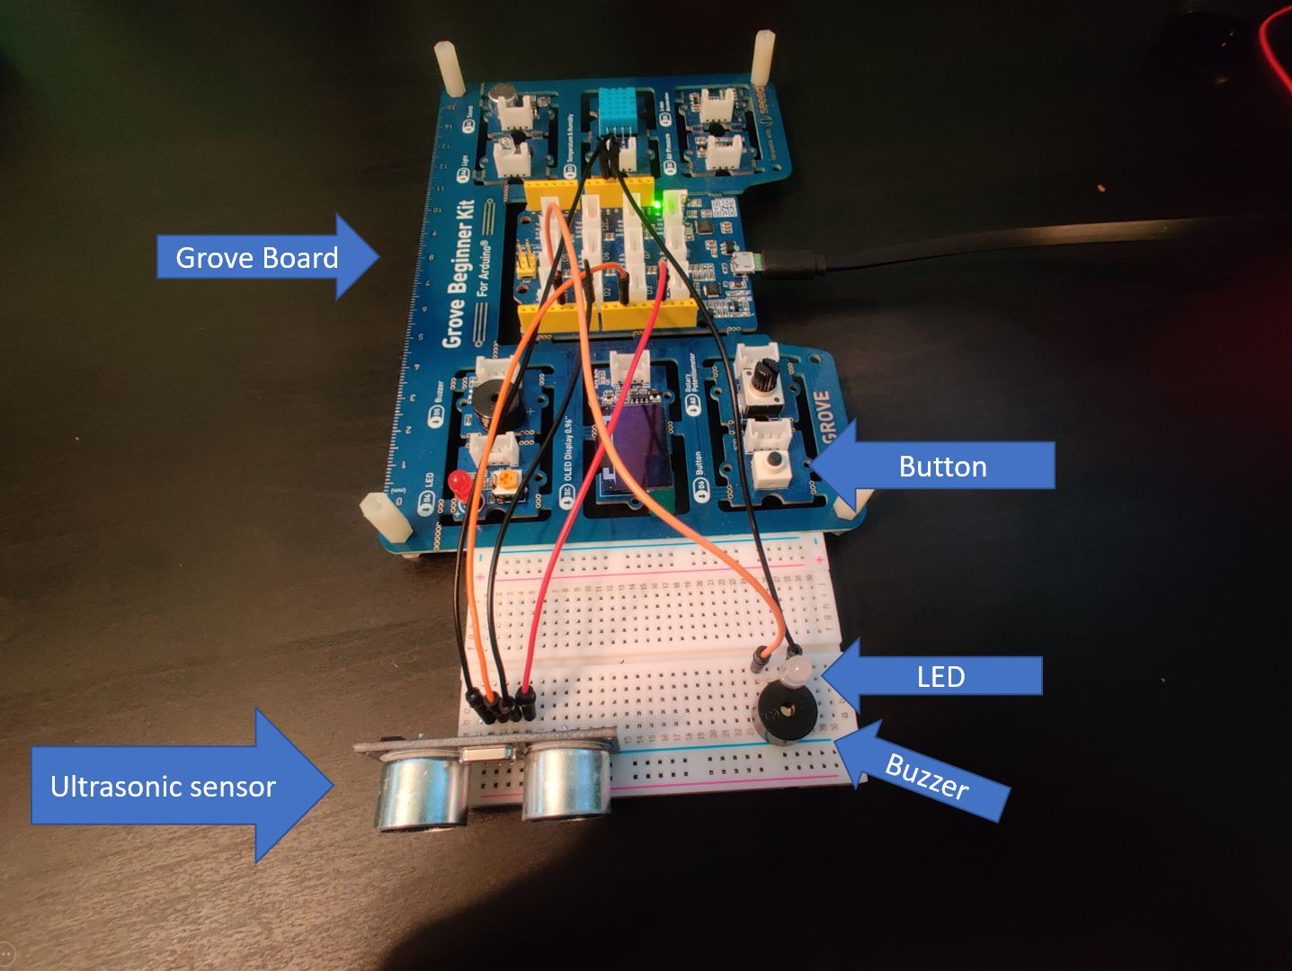

**Procedure:**

When I was testing out my idea and its feasibility, I did all my initial coding in the Arduino IDE. At first, I was experimenting with the ultrasonic sensor and was learning how to use it. Unfortunately, it was a lot more complicated to code than I expected. There was a bunch of calculations and processes that were involved in getting the sensor to operate. Some of the calculations included using the speed of sound when calculating distance in front of the sensor.

The next obstacle was to somehow get the buzzer to be activated when the ultrasonic senses a change in distance. I did this by adding an if/else statement that sent a signal to the buzzer when there was a substantial change in the distance (either larger to smaller). Following the success of the buzzer, I easily connected a LED by using the same positive and ground connections that the buzzer was using. This allowed me to add additional functionality without needing to write additional code.

Now that the idea was successful on the Arduino IDE, it was now time to translate the code to MATLAB. To my dismay, MATLAB has a dedicated function for the ultrasonic sensor, meaning that the multiple lines of code that I had wrote just for the sensor in the Arduino IDE was summed up in one line of code in MATLAB. Nonetheless, this made transferring the code over much easer. One thing that I had to adapt during the transfer would be caused by the fact that the ultrasonic function in MATLAB used a different metric compared to the Arduino IDE code that I had made. I used trial-and-error to see what variable values that would work best to allow the buzzer to work.

Side note: I used an external buzzer and LED even though the Grove board already had those components because the ones that were on my grove board were too quiet and dim, respectively.

**Test:**

My testing method was simple: just wave my hand in front of the sensor and see if the buzzer goes off. The Ultrasonic Buzzer was designed to buzz when sensing a change in distance and stop when the distance in front of it stays constant. So, when I went to test it, it had to complete that criteria.

**Contingency:**

Before I decided on the ultrasonic buzzer as my project, I tried out two other ideas. The first idea was to build a sumobot competition robot. In sumobot, the goal is to push your opponent’s robot off the circular arena. The robot is composed of a multitude of wheels, different sensors, batteries, a case, and much more depending on how ambitious you are. When I was pursuing this idea, I programmed the robot to be able to activate its motor and wheels. But I ran into the roadblock of the object sensing. I did not know how to program my robot to sense objects and move towards them. Because of the complexity of the project and my basic knowledge of Arduino, I made the decision to try something simpler. But even though I did not successfully complete a sumobot doesn’t mean that I won’t try again. One of my goals is to build a fully functional sumobot that can be used in competitions.

The next idea that I tried was to do an automatic streetlight. Basically, the project had a photoresistor and a LED. The photoresistor that would sense how bright the area was. If it was bright, then the LED would stay off. If the area was dark, then the LED would turn on. The code composed of a simple if-else statement. Although the project worked and would have been suitable to use for the major project, I felt as if it was too simple and felt that I could do better. The device also did not meet the requirements of the sensors and actuators that the major project’s rubric required.

**Additional Material:**

The most basic thing the Ultrasonic Buzzer can be used for is as an electric door chime. But my sensor and code can do more than just activate buzzers and LEDs (as was displayed in this project). With small modifications it can be implemented into many different situations. Automatic doors can be done by placing the sensor on top of it and changing the code to output a signal to open the door, similar to the current code that activates the buzzer/LED. Security systems can use the sensor to detect movement and activate an alarm. Or it can signal a security camera to start recording when it detects movement. The use of my sensor can be implemented in many different ways and benefits society with things that we take for granted and never think about.

**Conclusion:**

Although I had some struggle when choosing an idea, I am happy with the project that I eventually chose. The Ultrasonic buzzer is a project that forced me to learn more about Arduino and coding. Applying my knowledge from the course and the extra research that I had to do, I found that I have grown as a person.